Hadoop Installation Guide and Environment Setup

Refer to：

[ssh - How Do I Build Hadoop From Source Without Errors - Stack Overflow](https://stackoverflow.com/questions/31463763/how-do-i-build-hadoop-from-source-without-errors/31463764#31463764)

https://blog.csdn.net/m0_38139250/article/details/121714988?utm_source=miniapp_weixin

Installing Environment：

VirtualBox version 6.1.30

CentOS 7 Minimal

WinSCP version 6.1.1

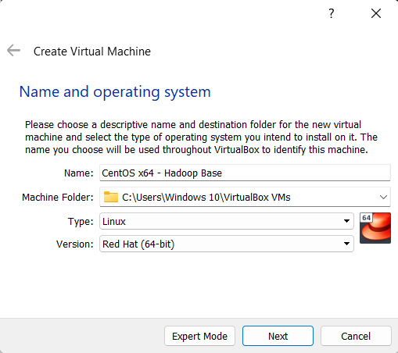

CentOS 7

阿里云mirror address：<http://mirrors.aliyun.com/centos/7/isos/x86_64/?spm=a2c6h.25603864.0.0.2d8d45111HoMh9>

WinSCP version 6.1.1

Download link：<https://winscp.net/eng/download.php>

JAVA 7 JDK (version 1.7.0_79)

Download link：https://www.oracle.com/java/technologies/javase/javase7-archive-downloads.html

File name：jdk-7u79-linux-x64.rpm